Skyline Small Molecule Targets

The Skyline Targeted Mass Spectrometry Environment provides informative visual displays of the raw mass spectrometer data you import into your Skyline documents. Originally developed for proteomics use, Skyline has been extended to work with generalized molecules. There are many tutorials available that will help you use Skyline for various types of analysis (SRM, PRM, MS1 Filtering, DIA, etc). This tutorial concentrates on the differences in using Skyline for targeting non-proteomic molecules.

In this tutorial, you will build an SRM assay for a group of Methionine-pathway compounds.

Skyline aims to provide a vendor-neutral platform for targeted quantitative mass spectrometry research. It can import raw data from the instrument vendors Agilent, Bruker, SCIEX, Shimadzu, Thermo-Scientific and Waters. The ability to import data across various instrument platforms greatly facilitates dissemination of reproducible methods, skill transfer across labs, cross-instrument comparisons and large multi-site studies. This remains equally true in using Skyline to target generalized molecules, as it has been for years in the field of proteomics.

# Getting Started

To start this tutorial, download the following ZIP file:

<https://skyline.ms/tutorials/SmallMolecule_3_6.zip>

Extract the files in it to a folder on your computer, like:

C:\Users\bspratt\Documents

This will create a new folder:

C:\Users\bspratt\Documents\SmallMolecule

It will contain all the files necessary for this tutorial.

If you have been using Skyline prior to starting this tutorial, it is a good idea to revert Skyline to its default settings. To do so:

* Start Skyline.
* On the **Start Page,** click **Blank Document** which looks like this:

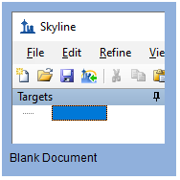

* On the **Settings** menu, click **Default.**
* Click **No** on the form asking if you want to save the current settings.

The document settings in this instance of Skyline have now been reset to the default.

Since this tutorial covers a small molecule topic, you can choose the molecule interface by doing the following:

* Click the user interface control in the upper right-hand corner of the Skyline window, and click **Molecule interface** which looks like this:

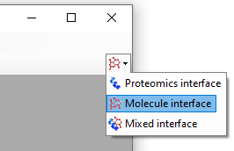

Skyline is operating in molecule mode which is displayed by the molecule icon  in the upper right-hand corner of the Skyline window. Its original proteomics menus and controls are now hidden, allowing you to focus on small molecule analysis.

# Importing a Molecule Transition List into a Skyline Document

The easiest way to get a molecule transition list into a Skyline document is to start with an empty document and use the **Edit > Insert > Transition List** menu item.

At a minimum, Skyline needs to know the charge state and either the ion formula or *m/z* for each precursor and product. If no product ion information is present in a transition list, it is assumed to be a list of precursor targets. Repeated precursor information with different product information is assumed to indicate multiple transitions of a single precursor, just as with peptides.

### A note on ion formulas and adduct descriptions

In proteomics applications, Skyline can safely assume ionization by protonation. So, all that is needed to describe a charged peptide is its sequence and charge state. For generalized molecules, however, ionization can be achieved in a variety of ways (sodium gain, hydrogen loss, etc.). Such ionization modes can be specified in Skyline using adduct descriptions of the style described at <http://fiehnlab.ucdavis.edu/staff/kind/Metabolomics/MS-Adduct-Calculator/>, e.g “[M+Na]”, “[M-2H]”, “[2M+ACN+H]”, etc.

Adduct descriptions can also be used to indicate that a molecule is isotopically labeled. For example, the adduct “[M3Cl374H2-Na]” indicates that the molecule has three Cl atoms replaced by 37Cl, and four H atoms replaced by deuterium, and the molecule is ionized by loss of Na.

For molecules where the formula is unknown, a mass shift can be indicated by adduct. For example, “[M(-1.23)+H]” indicates that the molecule’s mass is 1.23 AMU less than its unaltered form, and the molecule is ionized by hydrogen gain.

For molecules where the means of ionization is unknown, an adduct can indicate just a charge. For example, “[M+3]” indicates charge state three. The *m/z* value will be 1/3 of the molecule mass. While it is possible to describe your transition list completely in terms of *m/z* values for both precursors and products, without a chemical formula Skyline cannot provide isotopic distributions. So chemical formulas for both the neutral molecule and adduct descriptions are preferred.

## Transition list insert

To begin creating your first Skyline document that targets non-proteomic molecules, do the following:

* Locate the “SMTutorial_TransitionList.csv” file in the tutorial folder and open it in Excel.

You should find the following values:

|  |  |  |  |  |  |  |  |  |  |
| --- | --- | --- | --- | --- | --- | --- | --- | --- | --- |
| Molecule List Name | Precursor Name | Precursor Formula | Precursor Adduct | Precursor Charge | Precursor RT | Precursor CE | Product m/z | Product Charge | Label |
| Amino Acid | Methionine | C5H11NO2S | [M+H] | 1 | 2.5 | 15 | 104.07 | 1 |  |
| Amino Acid | Methionine | C5H8H'3NO2S | [M+H] | 1 | 2.5 | 15 | 107.09 | 1 | heavy |
| Amino Acid | Isoleucine | C6H13NO2 | [M+H] | 1 | 2.9 | 15 | 86.096 | 1 |  |
| Amino Acid | Leucine | C6H13NO2 | [M+H] | 1 | 3 | 15 | 86.096 | 1 |  |
| Amino Acid | Leucine | C6H10H'3NO2 | [M+H] | 1 | 3 | 15 | 89.1 | 1 | heavy |
| Amino Acid | Phenylalanine | C9H11NO2 | [M+H] | 1 | 3.1 | 15 | 120.08 | 1 |  |
| Amino Acid | Phenylalanine | C9H11NO2 | [M6C13+H] | 1 | 3.1 | 15 | 126.11 | 1 | heavy |
| Amino Acid | Arginine | C6H14N4O2 | [M+H] | 1 | 2.01 | 15 | 116.07 | 1 |  |
| Amino Acid | Arginine | C1C'5H14N4O2 | [M+H] | 1 | 2.01 | 15 | 121.11 | 1 | heavy |
| Amino Acid | Ornithine | C5H12N2O2 | [M+H] | 1 | 0.85 | 15 | 70.07 | 1 |  |
| Amino Acid | Ornithine | C5H12N2O2 | [M+H] | 1 | 0.85 | 15 | 116.07 | 1 |  |
| Amino Acid | Ornithine | C5H10H'2N2O2 | [M+H] | 1 | 0.85 | 15 | 72.07 | 1 | heavy |
| Amino Acid | Ornithine | C5H10H'2N2O2 | [M+H] | 1 | 0.85 | 15 | 118.07 | 1 | heavy |
| Organic Acid | creatine | C4H9N3O2 | [M+H] | 1 | 1.1 | 15 | 90.06 | 1 |  |
| Organic Acid | creatine | C4H6H'3N3O2 | [M+H] | 1 | 1.1 | 15 | 93.06 | 1 | heavy |
| 5'-methylthioadenosine | MTA | C11H15N5O3S | [M+H] | 1 | 3.4 | 15 | 136.1 | 1 |  |
| 5'-methylthioadenosine | MTA | C11H12H'3N5O3S | [M+H] | 1 | 3.4 | 15 | 136.1 | 1 | heavy |
| S-adenosyl methionine | SAM | C15H22N6O5S | [M+H] | 1 | 2.9 | 15 | 250.11 | 1 |  |
| S-Adenosyl homocysteine | SAH | C14H20N6O5S | [M+H] | 1 | 2.9 | 15 | 136.08 | 1 |  |
| Polyamine | Spermidine | C7H19N3[M+H] |  | 1 | 3.3 | 15 | 129.15 | 1 |  |
| Polyamine | Spermine | C10H26N4 | [M+H] | 1 | 3.5 | 15 | 112.112 | 1 |  |

* Select the transition list rows and columns in Excel, including the header row, and **Copy** (Ctrl-C).
* On the Skyline **Edit** menu, choose **Insert** and click **Transition List**.

Skyline will show the **Insert Transition List** form which should look like this:

* Press **Ctrl-V** to paste the information you placed on the clipboard into Skyline.

Skyline will show **the Import Transition List: Identify Columns** form:

* Make sure the **Molecules** button is pressed.

Note that each column has a drop-down control where you can specify the type of column. In this case, Skyline successfully identifies all the necessary columns.

* Click the **OK** button.

## Further notes on ion formulas and adduct descriptions

In this example, there are some light-heavy isotope label pairs, e.g. Methionine and d3-Methionine. In the transition list they are described as **C5H11NO2S [M+H]** and **C5H8H'3NO2S [M+H]**, but using the language of adduct descriptions they could also have been described as **C5H11NO2S [M+H]** and **C5H11NO2S [M3H2+H].** You can see an example of this in the Phenylalanine heavy-light pair: the formulas are the same but the heavy adduct description specifies that 6 carbons are replaced with C13. Note that the Adduct column is optional: as in the example of Spermidine, the adduct can be given as part of the ion formula. Note also that the Precursor Charge column is not actually needed: the charge states can be inferred from the adduct descriptions. The Label column is also not strictly needed: the heavy label can be inferred from the precursor ion formula and/or adduct.

|  |
| --- |
| Note: You could also have used the **File > Import >Transition List** menu item to import the file directly, without the need for opening it and copying and pasting its contents. |

Your Skyline window should now look like this:

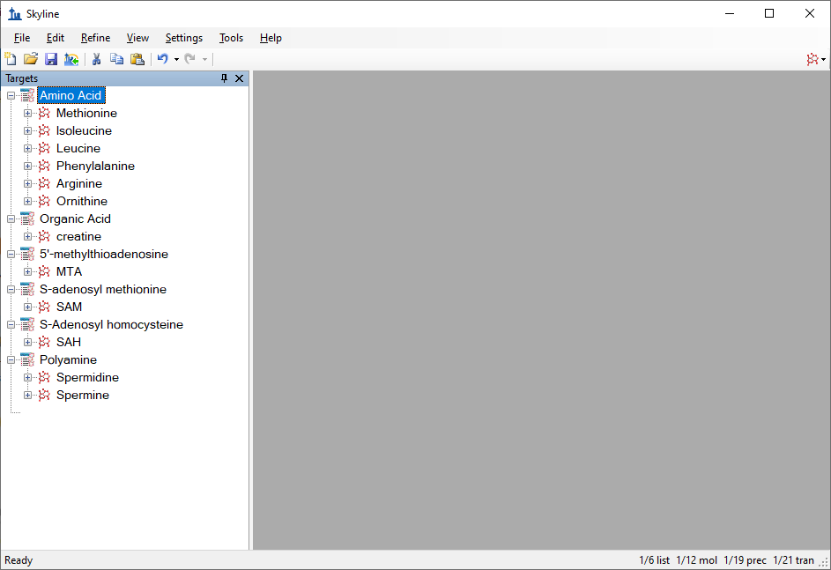

At this point, either a native instrument method, precursor isolation list (for PRM) or transition list (for SRM) can be exported. For more details on how to perform this step, please see the [Targeted Method Editing](https://skyline.ms/tutorial_method_edit.url), [Existing and Quantitative Experiments](https://skyline.ms/tutorial_existing_quant.url) or [Targeted MS/MS (PRM)](https://skyline.ms/tutorial_targeted_msms.url) tutorial.

# Importing Mass Spectrometer Runs

In this tutorial, you will simply import raw data from a Waters Xevo TQS instrument acquired using a MassLynx instrument method exported by Skyline. To do this now, perform the following steps.

* On the **File** menu, click **Save**. (Ctrl-S)
* Save this document as “Amino Acid Metabolism.sky” in the tutorial folder you created.
* On the **File** menu, choose **Import** and click **Results**.
* In the **Import Results** form, choose **Import single-injection replicates in files**.
* In the **Files to import simultaneously** dropdown list at the bottom of the form, click **Many** which will provide the best import performance.
* Click the **OK** button.
* Select all 18 raw data folders in the tutorial folder by clicking the first listed and then holding down the Shift key and clicking the last.

The **Import Results Files** form should look like this:

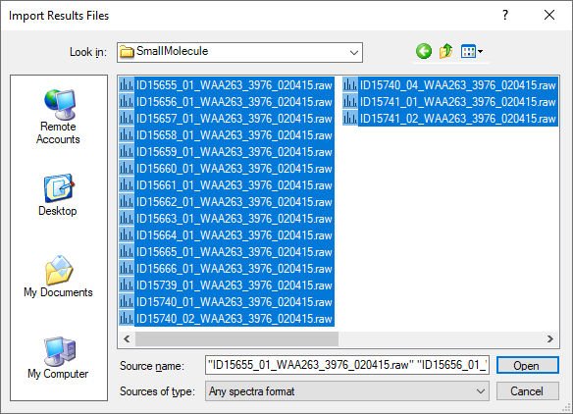

* Click the **Open** button.
* In the **Import Results** form, choose the **Do not remove** option when asked about removing the common prefix.
* Click the **OK** button.

The files are a metabolite extract of cancer cell lines under specific amino acid deprivation conditions, where cells were deprived of either the amino acid Methionine, or Arginine, or both, for a period of 3 hours versus control (all amino acids).1

Filenames and Conditions:

ID15739_01_WAA263_3976_020415 – Double Blank

ID15740_01_WAA263_3976_020415 – Extraction Blank (contains SIL standards)

ID15740_02_WAA263_3976_020415 – Extraction Blank (contains SIL standards)

ID15740_04_WAA263_3976_020415 – Extraction Blank (contains SIL standards)

ID15655_01_WAA263_3976_020415 – All AA Sample 1

ID15656_01_WAA263_3976_020415 – All AA Sample 2

ID15657_01_WAA263_3976_020415 – All AA Sample 3

ID15658_01_WAA263_3976_020415 – Minus Met Sample 1

ID15659_01_WAA263_3976_020415 – Minus Met Sample 2

ID15660_01_WAA263_3976_020415 – Minus Met Sample 3

ID15661_01_WAA263_3976_020415 – Minus Arg Sample 1

ID15662_01_WAA263_3976_020415 – Minus Arg Sample 2

ID15663_01_WAA263_3976_020415 – Minus Arg Sample 3

ID15664_01_WAA263_3976_020415 – Minus Arg, Minus Met Sample 1

ID15665_01_WAA263_3976_020415 – Minus Arg, Minus Met Sample 2

ID15666_01_WAA263_3976_020415 – Minus Arg, Minus Met Sample 3

ID15741_01_WAA263_3976_020415 – Pooled QC Sample 1

ID15741_02_WAA263_3976_020415 – Pooled QC Sample 2

The files should import within a matter of seconds, leaving your Skyline window looking like this:

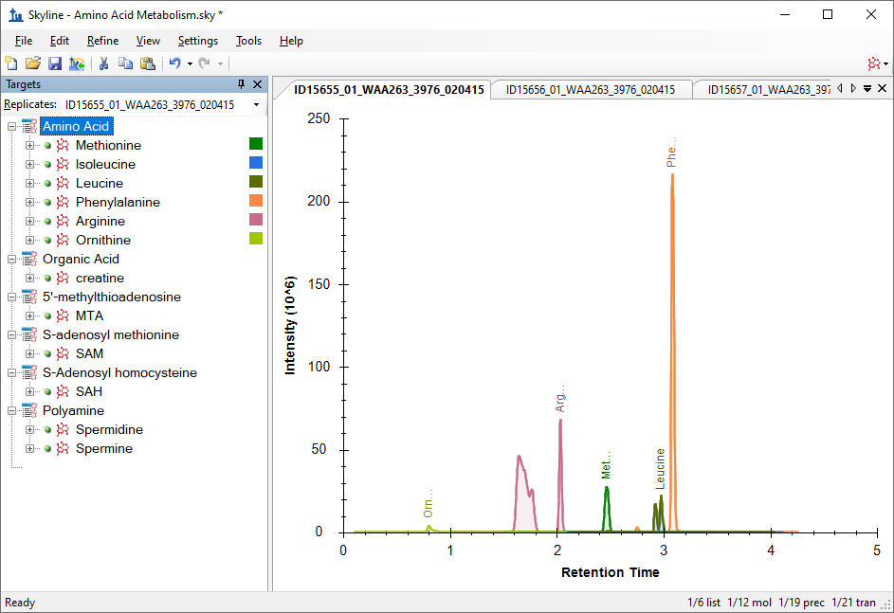

To take advantage of the Skyline summary graphs for viewing individual targets, do the following:

* On the **View** menu, choose **Peak Areas** and click **Replicate Comparison**.
* On the **View** menu, choose **Retention Times** and click **Replicate Comparison.**
* Click and drag these views to dock them above the chromatogram graphs.
* Select the first target “Methionine” in the **Targets** view.

The Skyline window should now look like this:

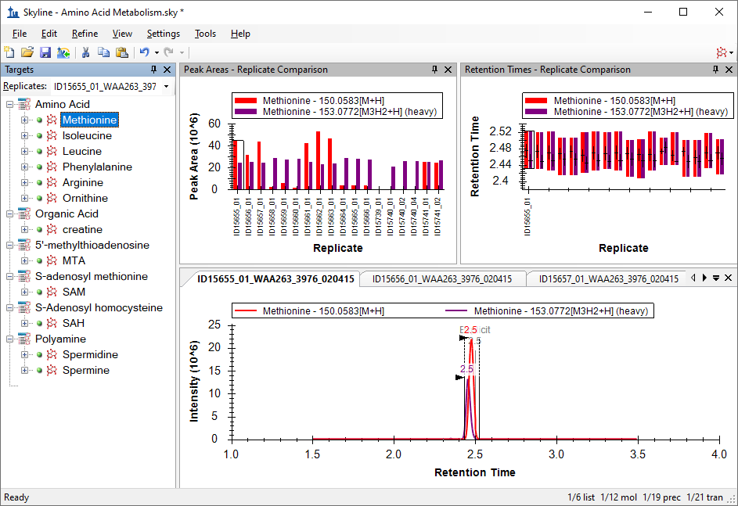

# Conclusion

In this tutorial, you have learned how to create a Skyline document that targets molecules specified as precursor ion chemical formulas and adducts, and product ion *m/z* values. You imported a multi-replicate data set collected by a metabolomics researcher, and saw how many existing Skyline features created initially for targeted proteomics use can now be applied to non-proteomic molecule data.

# Bibliography

1. Tang, X. *et al.* Comprehensive Profiling of Amino Acid Response Uncovers Unique Methionine-Deprived Response Dependent on Intact Creatine Biosynthesis. *PLoS Genet* **11,** e1005158 (2015).